MA4830 Log sheet – Baick Geunmyeong
Week 1:
During the team introduction phase, we analyzed previous competition videos to identify successful strategies and common challenges. As part of the robot actuation team, my primary focus was on optimizing the robot's center of gravity and drive system configuration. Inspired by previous competitions, I proposed implementing a rubber band gripper mechanism in the first week. Through extensive research of YouTube evaluations and competition footage, I identified three critical areas for improvement: insufficient torque leading to robot immobilization, boundary violation issues, and difficulty in edge ball collection. These became my primary design objectives for the initial development phase.
Week 2:
Briefing on the design project, forming of groups. I decided to take parts in Robot actuation, power supply and electrical supplies, initially.
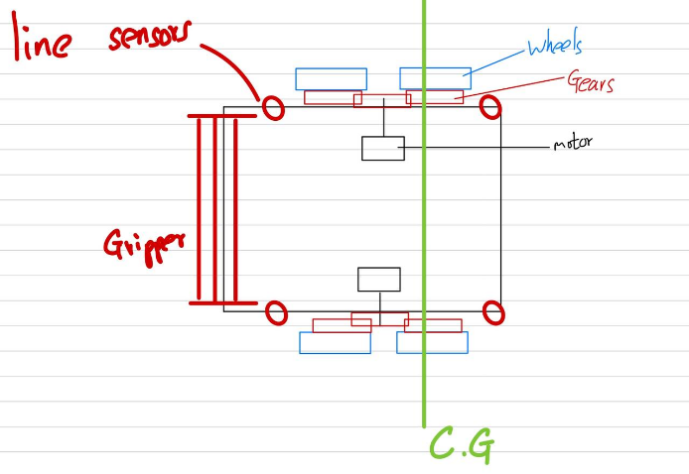
Initial Design Proposals
I created detailed diagrams outlining my proposed robot design, focusing on three key aspects:
- Edge ball collection capability
- Rear-biased center of gravity for improved stability
- Specialized edge ball gripping mechanism
While another team member suggested a four-wheel configuration, I initially advocated for a two-wheel system with a central ball roller due to concerns about wheel skidding.
Week 3: Design Refinement
I conducted extensive research on optimal robot design, analyzing previous competition videos. Key decisions included:
- Positioning the center of gravity slightly rearward to maintain stability with the gripping roller
- Implementing a rolling rubber band gripper system based on successful previous designs
- Strategic placement of IR sensors behind the gripper to optimize edge ball detection
- Created detailed hand-drawn schematics for:
- Wheel configuration and placement
- Ball collection mechanism
- IR sensor positioning
- Center of gravity distribution
- Ball release mechanism design
Suggested the high torque strategy. As I identified the speed and torque are the main factors for robot performance. We decided to focus on the torque first. With Goh’s idea on using gear ratio design structure, we tried to implement.
Week 4: Initial Component Testing
With the arrival of our development components, I collaborated with the gripper team to:
- Test the rubber band gripping roller's ball collection effectiveness
- Evaluate the mechanism's performance through multiple trials
- Work with team members to determine optimal height specifications for gripper attachment
- Ensure proper alignment between the gripper and robot body
The initial testing showed partial success, prompting further refinement of the gripper's positioning and attachment specifications to optimize ball collection performance.
Week 5: Drive System Development
- Retrieved and tested the ball wheel from the lab for potential stability enhancement
- Implemented a four-wheel drive system despite initial concerns about skidding
- Successfully tested the driving program, achieving effective pivot turns
- Recognized the four-wheel system's advantages in directional stability
- Documented concerns about potential energy loss through skidding
Week 6: Integration Phase
- Supported the gripper team during their assembly process
- Maintained communication for seamless integration of components
Week 7: Documentation and Sensor Optimization
- Authored sections of the technical report covering:
- Speed/torque specifications
- Drive system design
- Component placement diagrams
- Center of gravity calculations
- Collaborated on report formatting and additional design concepts
- Conducted video of robot behavior
- Focused on sensor placement optimization:
- Tested various configurations for distance sensors
- Identified issues with wall boundary detection
- Explored sensor placement within the ramp structure
- Evaluated horizontal vs. vertical sensor orientations
- Determined vertical placement provided superior detection results
The team successfully implemented a four-wheel drive system that proved more stable than the initial two-wheel design, despite concerns about skidding. We made significant progress in sensor optimization, particularly with the distance sensors, where we discovered that vertical placement within the ramp structure provided the most reliable detection results. The documentation process helped solidify our design decisions and provided a clear record of our development progress.
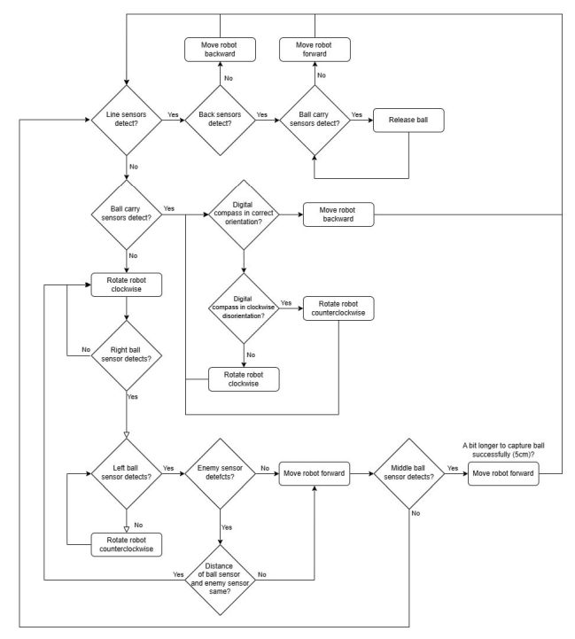
Initial code block diagram was made. We did trial and error methods to make the robot actuation process smoother.

Week 8
Time: 1pm ~5.30pm, Mon, Tue, Wed, Thu
Transition to Software Development
Role Transition
Shifted focus from mechanical design to software development and testing as the mechanical aspects transitioned to 3D printing. This change allowed me to dedicate more time to programming and system testing, recognizing the approaching deadline.
Sensor Optimization
Developed an innovative sensor configuration to overcome detection limitations:
- Implemented a dual-sensor approach
- Positioned one sensor at an angle
- Placed another sensor facing forward
- This configuration significantly improved ball detection reliability
Time Management
Recognizing the limited time remaining, I increased my lab hours to ensure thorough testing and development of the robot's software systems.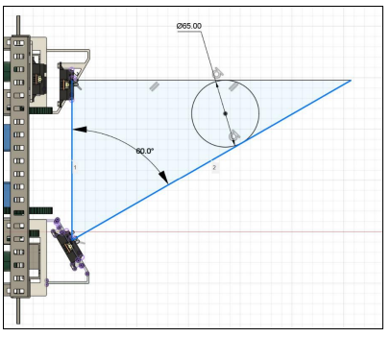
Distance Sensor Optimization
- Calculated optimal angle for the angled distance sensor based on:
- Minimum required detection distance
- Ball collection range requirements
- Implemented rear distance sensor for:
- Precise positioning at collection area
- Accurate distance measurement to collection boxes
Navigation System Development
- Initiated digital compass integration
- Focused on understanding compass mechanism
- Began calibration process for accurate orientation
- Developed reorientation algorithms based on compass readings
- Established reliable navigation protocols for arena positioning
During this phase, we focused on optimizing our sensor system and developing reliable navigation protocols. We calculated the optimal angle for the angled distance sensor, taking into account the minimum required detection distance and the robot's ball collection range. This was complemented by implementing a rear distance sensor to ensure precise positioning in the collection area. Simultaneously, we began integrating the digital compass system, dedicating significant time to understanding its mechanism and calibration process. This work laid the foundation for our reorientation algorithms, which would become crucial for accurate arena navigation and positioning. The combination of these sensor optimizations and navigation developments significantly improved the robot's ability to locate and collect balls while maintaining proper orientation within the competition area.

Week 9
Time: 1pm ~5.30pm, Mon, Tue, Wed, Thu
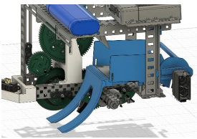
During this development phase, we encountered several critical issues with our initial implementation. The lack of detailed hardware considerations in the code structure led to problems with ball stability, particularly during rapid movements where balls would bounce or even exit the robot. We also faced challenges with the back distance sensor implementation, as its readings would drop dramatically when too close to walls, creating a detection gap between the required 1000+ value for ball release and the near-zero values during proximity. Despite these challenges, we successfully confirmed optimal sensor placement for ball detection, which allowed us to shift focus to improving the robot's ball collection acknowledgment system. This period highlighted the importance of thorough hardware-software integration and the need for more robust error handling in our code structure.
During this phase, we made a significant breakthrough in ball detection by repurposing the ramp's sensor hole for a limit switch. This strategic placement proved to be a game-changer, providing more reliable and efficient ball detection. The limit switch's binary nature (0 or 1) offered clearer detection signals compared to the previous sensor setup. This modification not only improved single ball detection but also effectively prevented the unintended collection of multiple balls, as the switch would trigger immediately upon ball contact, allowing the robot to stop and process the collection before attempting to gather additional balls. This solution elegantly addressed both the detection reliability and multiple ball collection issues we had been facing.

Week 10
Time: 1pm ~5.30pm, Mon, Tue, Wed, Thu
During this phase, we made significant changes to our sensor configuration. We removed the problematic back distance sensor and instead implemented a more reliable system using limit switches. Two limit switches were strategically placed as back bumpers to detect contact with the collection boxes, providing more consistent positioning feedback. While implementing the digital compass for robot alignment before ball delivery, we encountered stability issues with the reorientation function. These challenges appeared to stem from the digital compass's resolution limitations, which affected the precision of our alignment system. This period highlighted the importance of choosing the right sensors for specific tasks and the need to balance precision and reliability in our navigation systems.
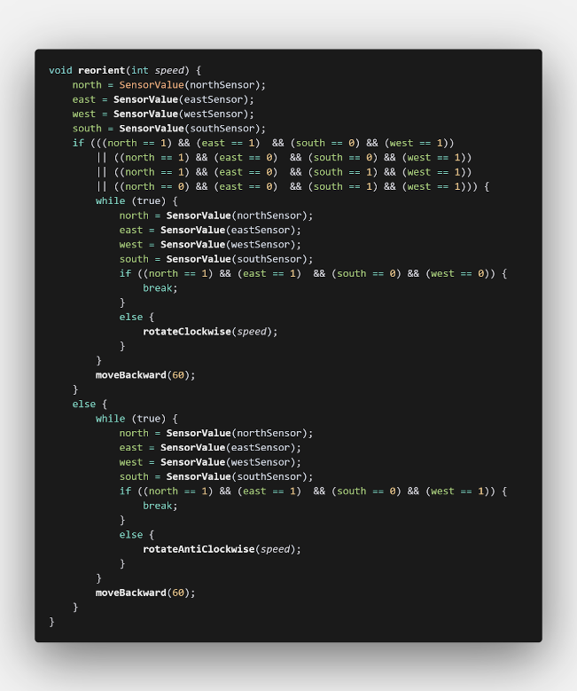
The reorient function was set to use the boundaries instead. 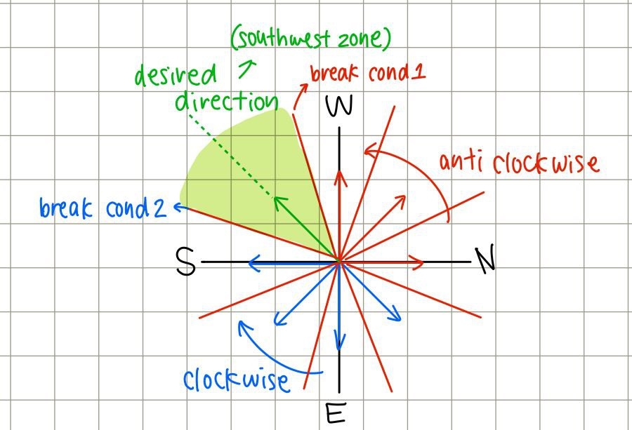
Figure Reorient Algorithm
The above figure was drawn by me, to help understand our reorientation process.
The `reorient()` function uses specific compass trigger points for precise alignment. When rotating counterclockwise, the function breaks upon detecting the southwest zone transition from west, positioning the robot along an optimal direction. Similarly, clockwise rotation stops when transitioning from south to southwest. While this dual-approach system ensures consistent orientation, the digital compass's inherent accuracy limitations occasionally resulted in slight alignment variations from the ideal position.
During this development phase, we addressed several critical hardware challenges. To prevent ball bouncing in the collection area, we implemented a one-way flapping gate that allowed balls to enter but not exit, significantly improving ball retention. However, we encountered issues with the ball release mechanism - the initial 3D-printed back gate was damaged during testing, revealing a more fundamental problem. The collection area's slope proved insufficient to effectively eject balls during release, causing them to remain trapped even when the release mechanism was activated. This discovery highlighted the need for both mechanical and design improvements to ensure reliable ball release functionality.

Week 11
Time: 1pm ~5.30pm, Mon, Tue, Wed, Thu
In Week 11, we addressed the issues identified in Week 10 by implementing appropriate mitigation measures. Occasionally, the ball would get stuck on the ramp, likely due to insufficient friction. To resolve this, we applied sandpaper to the ramp surface, which significantly improved friction and ensured the ball was collected reliably.
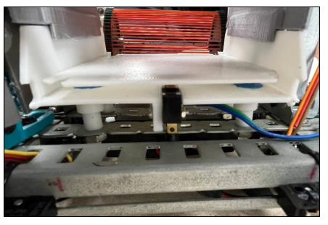
During testing, a major issue arose: the robot behaved as if it had collected the ball, even though it had not. At the time, we didn’t have a proper debug stream set up due to our limited experience, so we spent a considerable amount of time identifying the cause of this so-called “hallucination.” I hypothesized that the problem might be caused by the robot’s sudden jerks triggering the limit switch in the ball collection area, falsely signaling a successful pickup.
To address this, I proposed using a ballpoint pen spring beneath the plate to make the limit switch harder to trigger—resistant to false presses but still sensitive enough to respond to the weight of a real ball. We implemented this by cutting the spring in half and attaching it using Blu Tack. Initially, the modification didn’t work as expected. I then improvised by adding more Blu Tack to the opposite side of the plate, increasing its slope. Fortunately, this adjustment worked, and the hallucination issue was resolved.
Later, we further mitigated the problem through code improvements. The updated logic first checked whether the ramp limit switch was triggered, then waited 400ms before verifying the pickup limit switch. By the end of the week, we achieved a fully functional robot capable of searching for, collecting, and returning the ball to the box. However, there’s still room for improvement in certain edge cases, such as the robot getting stuck while returning or endlessly searching due to the current threshold setup.
Week 12
Time: 1pm ~5.30pm, Mon, Tue, Wed, Thu
Another issue arose in Week 12 when we attempted to modify the code and implement new features to address previous problems, including:
- Infinite returning,
- Continuous forward movement while searching (caused by detecting the high walls of the collection boxes), and
- Endless searching behavior.
We successfully resolved the infinite returning and forward movement issues using timer functions. However, after implementing the changes, the robot's performance declined—likely due to an overloaded super loop causing slower execution speed. As a result, the robot did not perform as well as it did in Week 11.
We attempted to roll back to the previous version of the code, but due to poor version control and multiple programmers contributing to the project, it was difficult to restore the working version. Despite these setbacks, we managed to re-implement the features, although with slightly reduced performance compared to Week 11, largely due to time constraints.

Week 13: Final week, Monday
Time: 9am – 4.30pm
We initially planned to hold a demo competition with the other team, but this was not possible as both teams were still finalizing their code.
During the actual competition, we encountered several hardware issues. After the second match, the 3D-printed front sensor mount was completely broken. With very limited time before our next match, we quickly repaired it using super glue.
Later in the competition, another issue arose: the rear left bumper limit switch broke due to a collision with another robot. To overcome this, we modified the code to rely solely on the right bumper switch, which proved effective. Despite these setbacks, we were able to adapt quickly and ultimately secured first place.
Following the competition, I focused on refining and documenting the code. This formed the majority of Part 7 of the final report. I dedicated time to thoroughly explain how each sensor and motor was implemented from a software perspective, along with detailed explanations of key code segments. We also held a Zoom meeting to finalize the documentation.
Evaluation:
Overall, one of the most valuable lessons I learned was the importance of the relationship between hardware and software. In robotics, these two components are deeply interconnected—they cannot be treated separately. Effective communication between hardware and software is essential for building a stable and reliable system.
Through this project, I also realized how critical sensor performance and strategic placement are. Issues like sensor inaccuracies and hardware breakdowns highlighted the importance of robust hardware design. While hardware fixes are often more difficult to implement, they tend to be more stable and reliable in the long run. On the other hand, software fixes can offer quick solutions but may create complications later if further changes are needed. Striking the right balance between hardware and software solutions is key to achieving optimal performance.
Another important takeaway was the value of communication and collaboration within a team. Every aspect of the project—3D printing, strategy, coding, and problem-solving—depended on each team member's contribution. Clear communication and teamwork were vital to our success.
Overall, I thoroughly enjoyed this project. It gave me hands-on experience in robotics and teamwork, and the technical and collaborative skills I gained will have a lasting impact on my future career.

